Laporan

MININET, MININAM, OpenFlow, dan POX Controller



Dosen Pengajar :  
Baihaqi Siregar, S.Si., MT.

Anggota Kelompok:

1. Ray Syadera Lingga 161402067
2. Annisa Ardina 161402039
3. Khairunnisa Husin Nasution 161402003
4. Amalia Khairina 161402117
5. Johanna Aulia 161402144

Kom C

Fakultas Ilmu Komputer dan Teknologi Informasi

Universitas Sumatera Utara

2018

**MININET :**

* **Import Appliance**

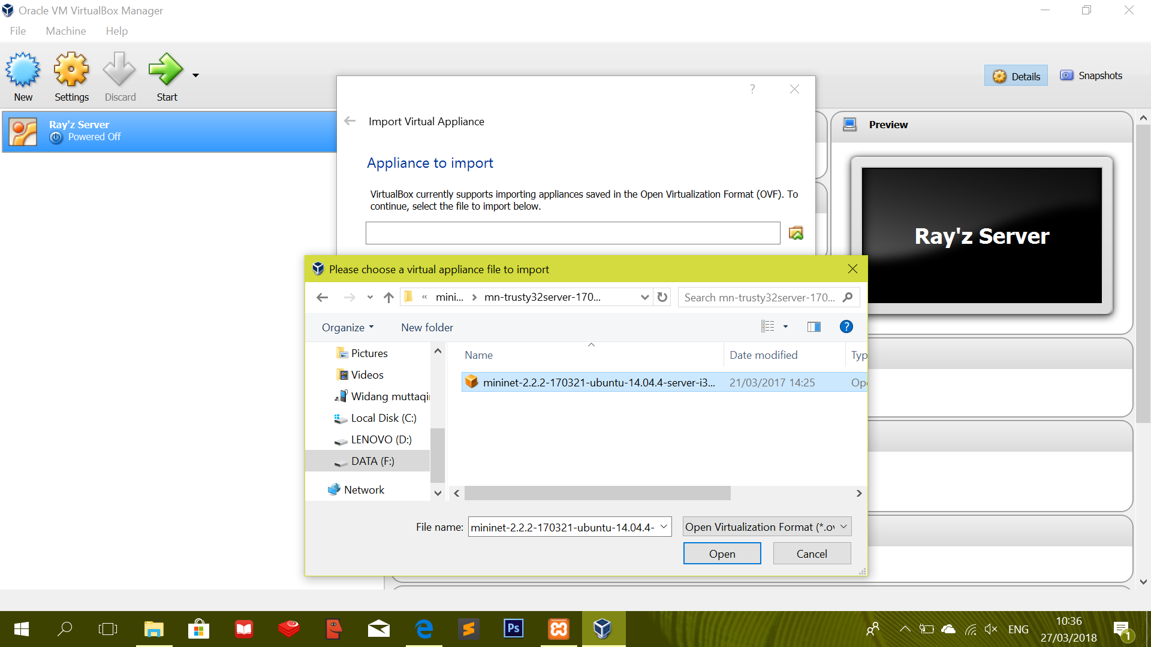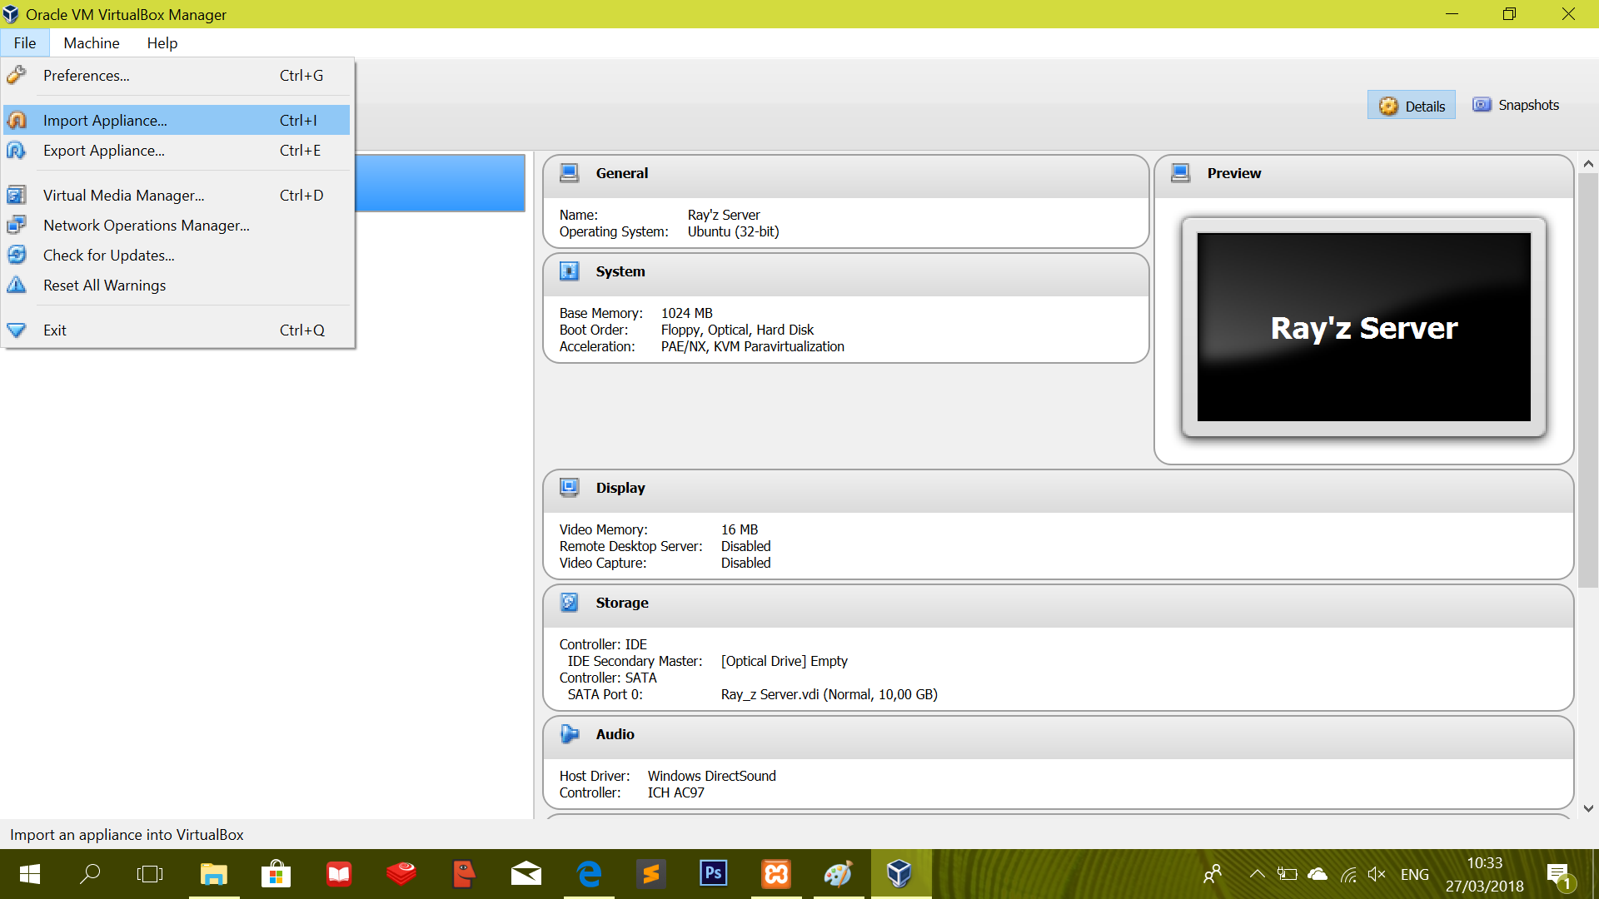

* **Configure Access**

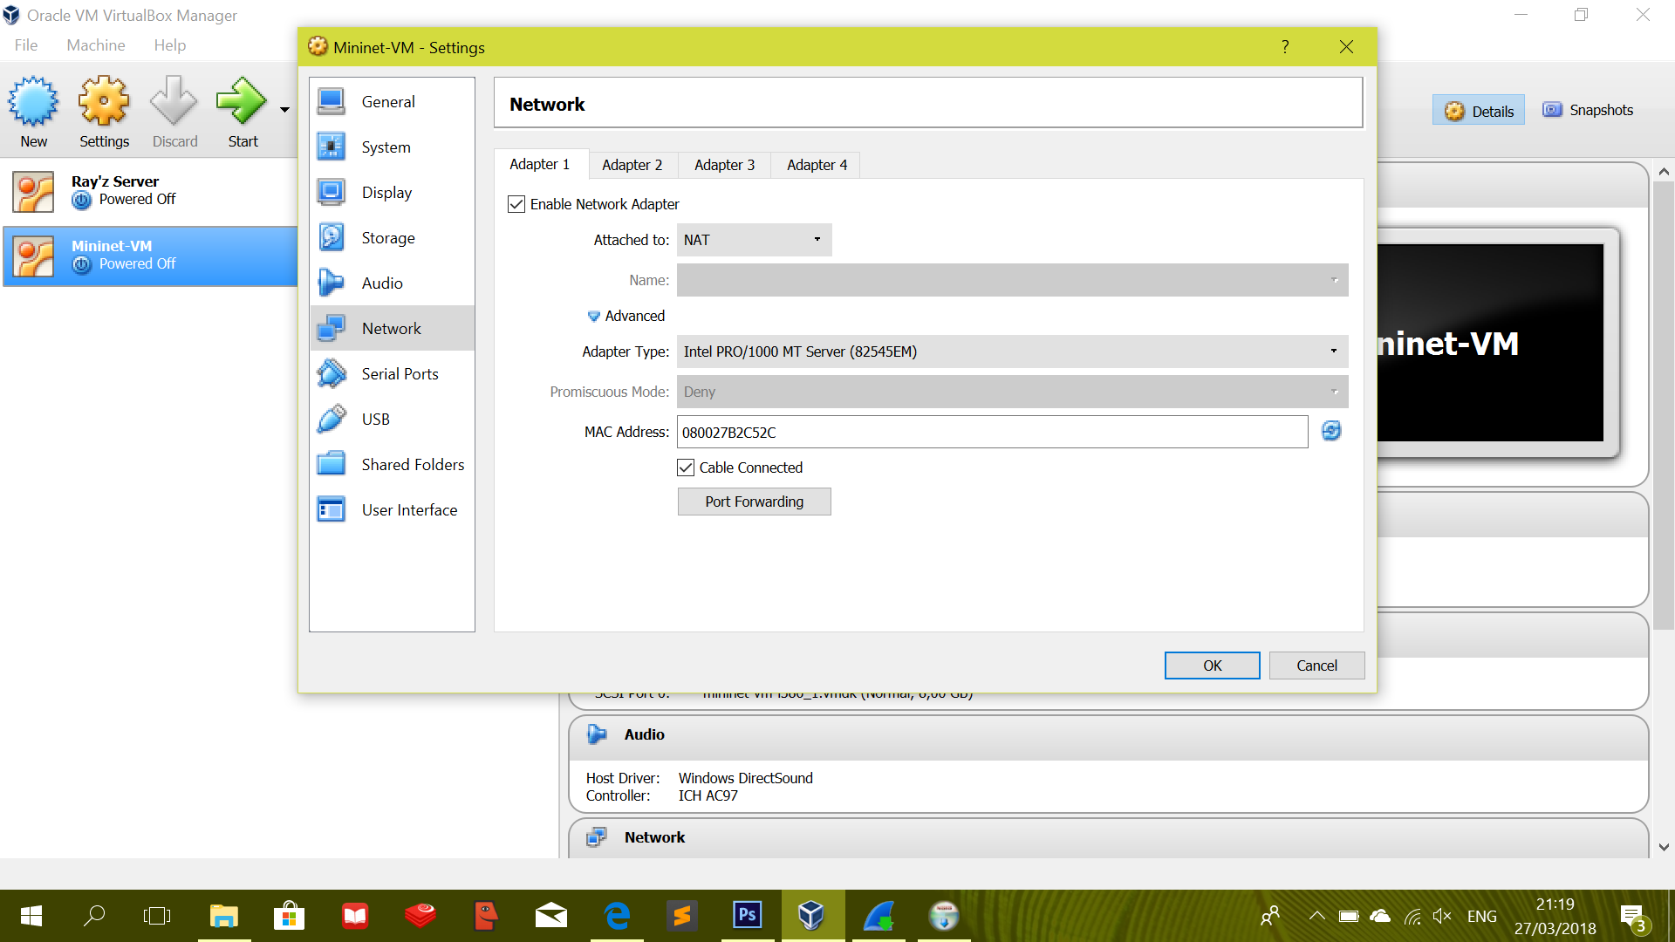

* **Port Forwarding**

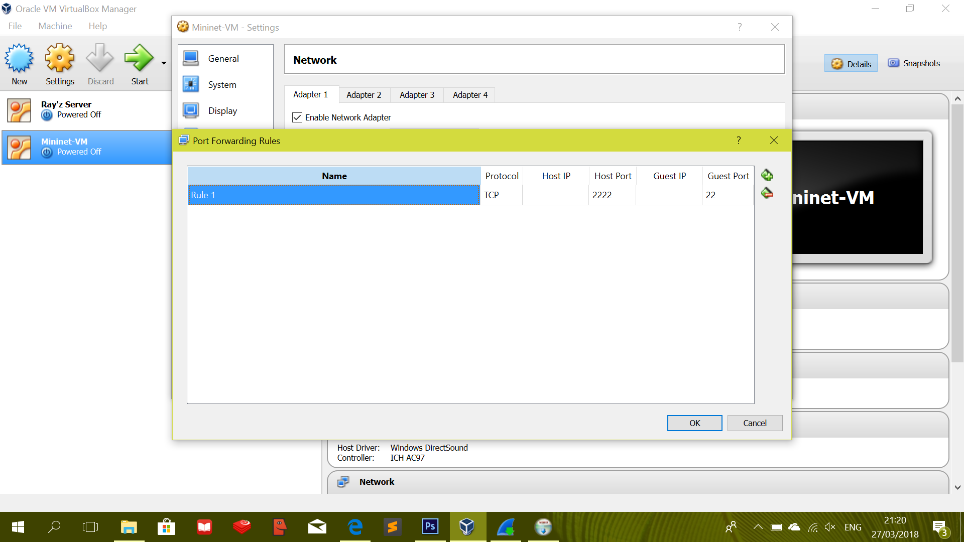

* **Access Via SSH**

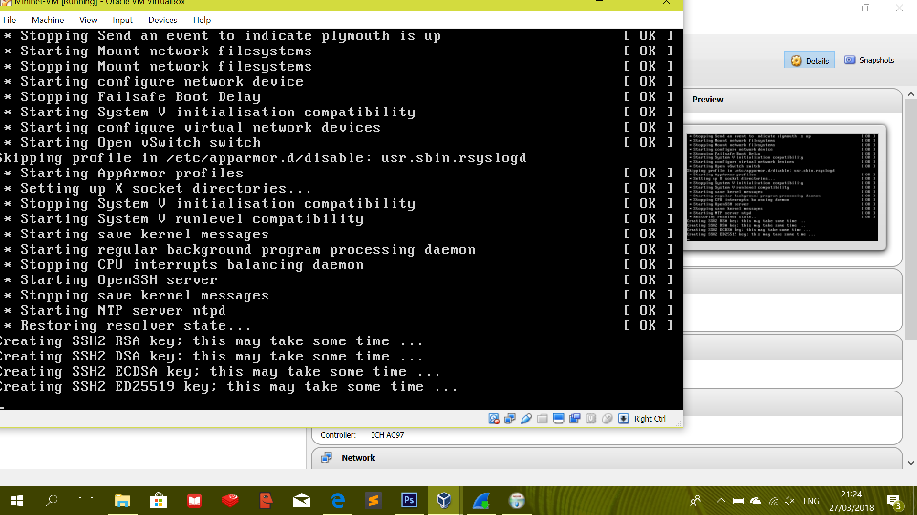

* **Test**

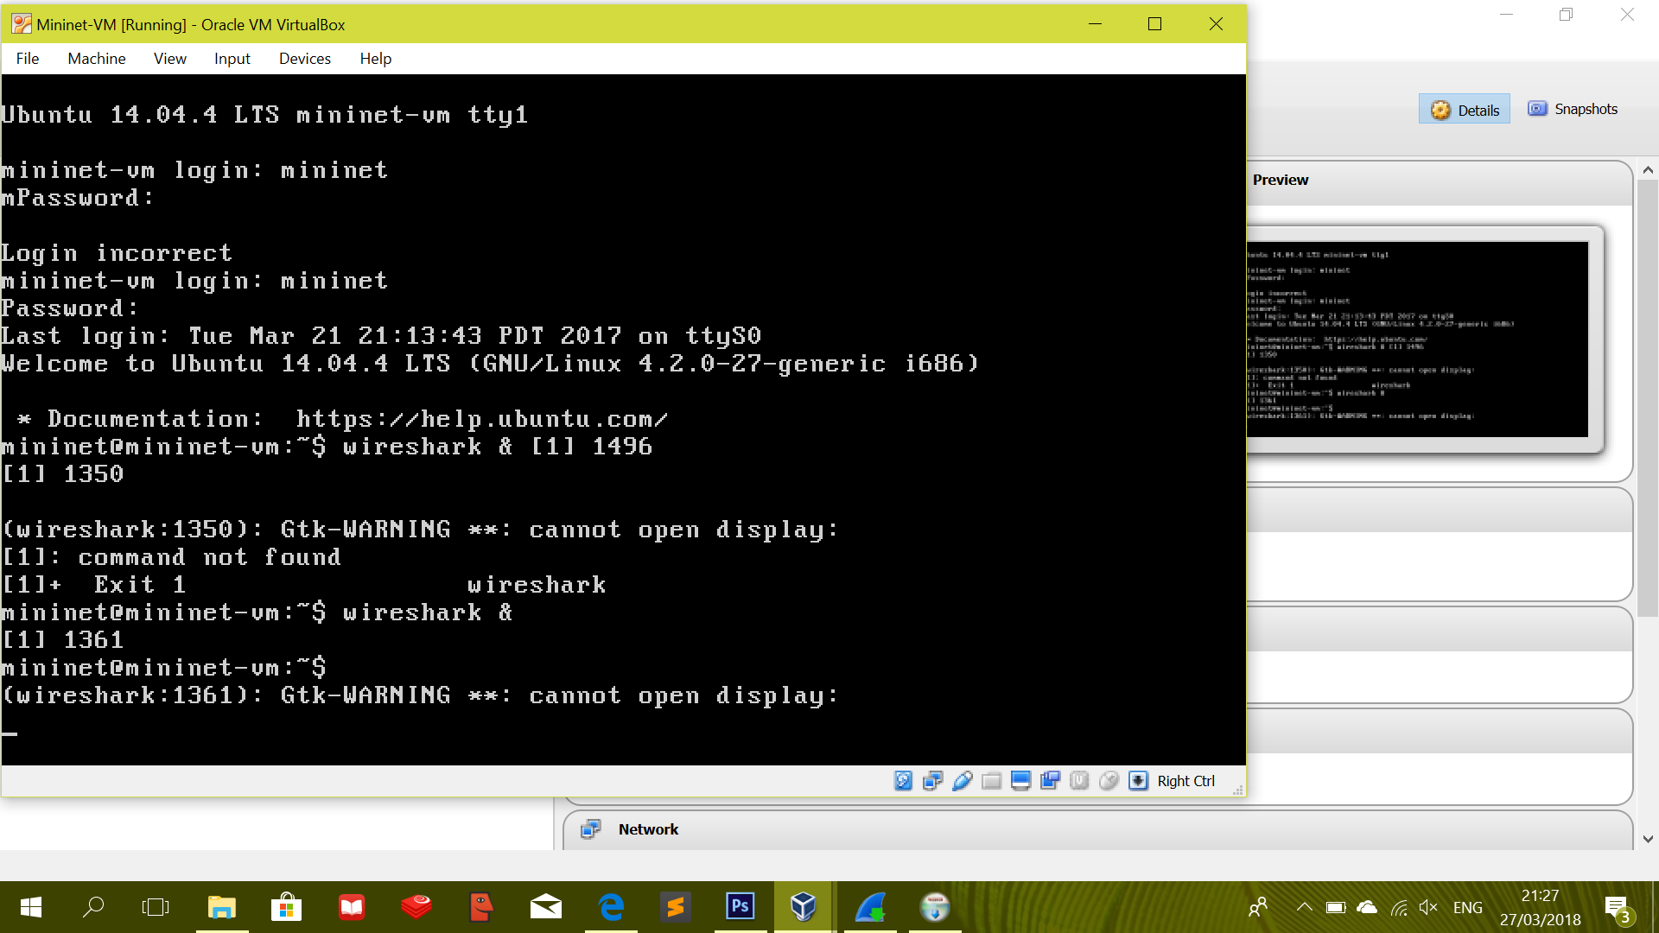

* **Test WireShark**

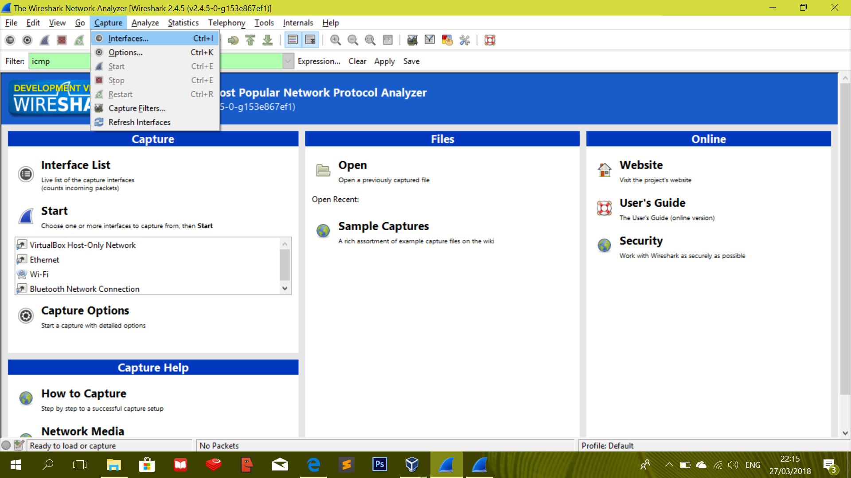

* **Check**

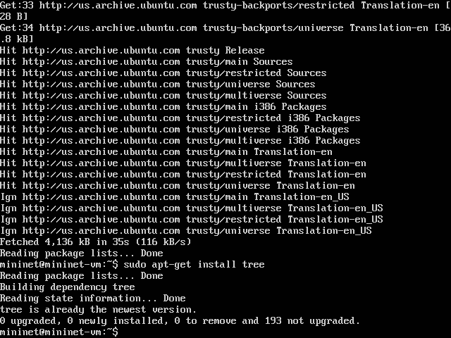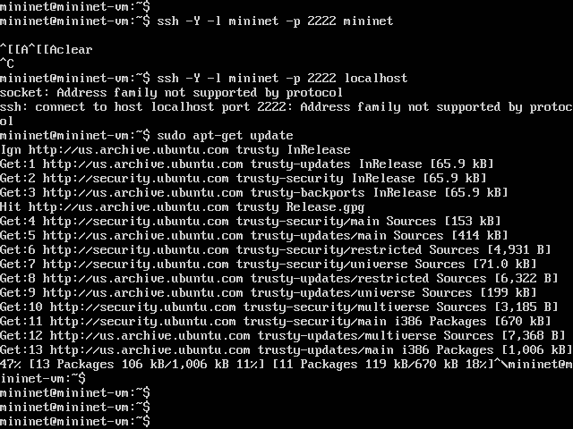

* **Tree –L 1**

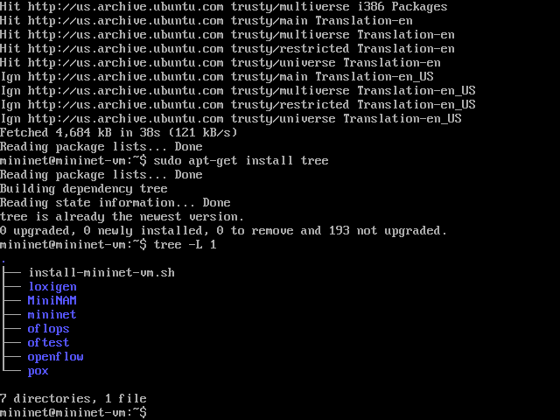

* **Tree –L 2 -d**

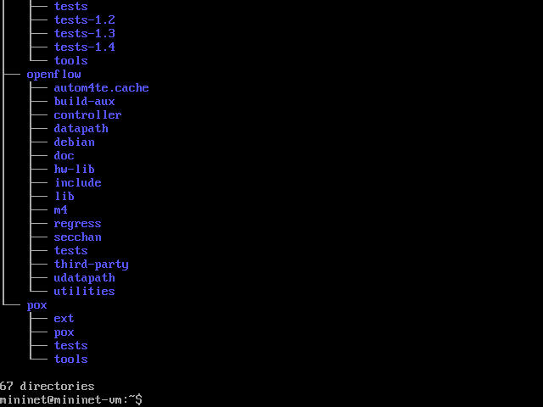

* **LL**

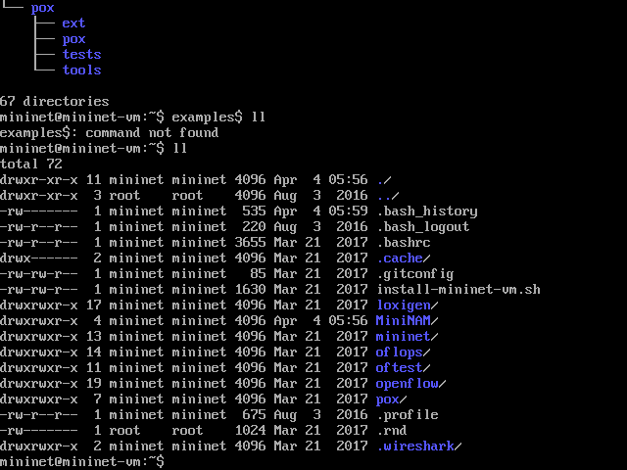

* **Sudo mn [--topo=minimal]**

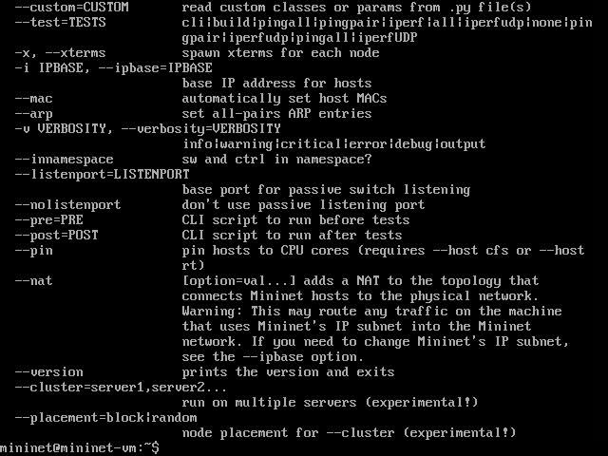

* **Sudo mn --test pingpair**

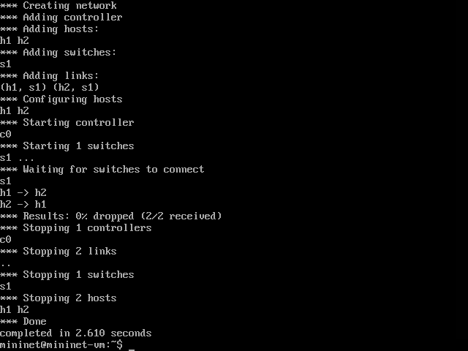

* **Sudo --test iperf**

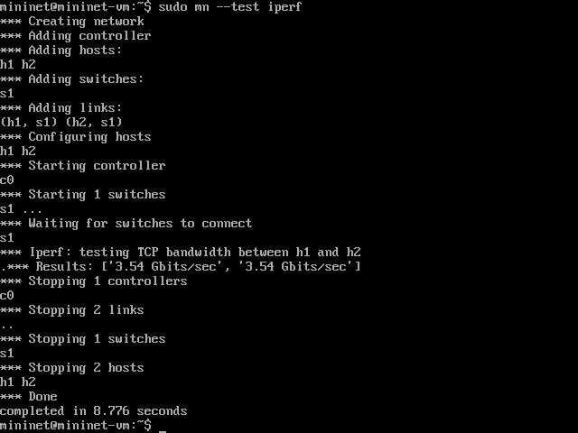

* **sudo mn –link tc,bw=10,delay=10ms**

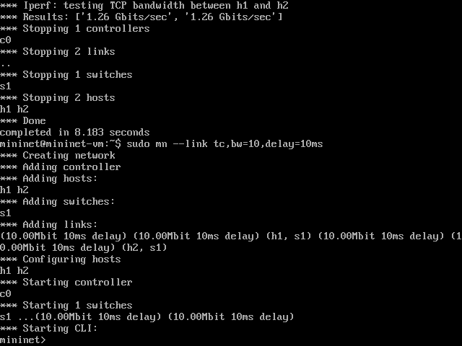

* **sudo mn –test pingall –topo single,3**

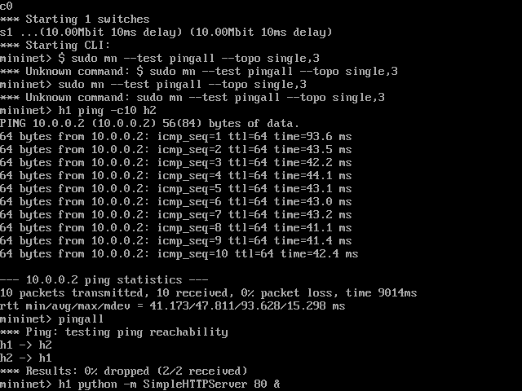

* **sudo mn –test pingall –topo mytopo –custom ~MiniNET/custom/topo-2sw-2host.py**

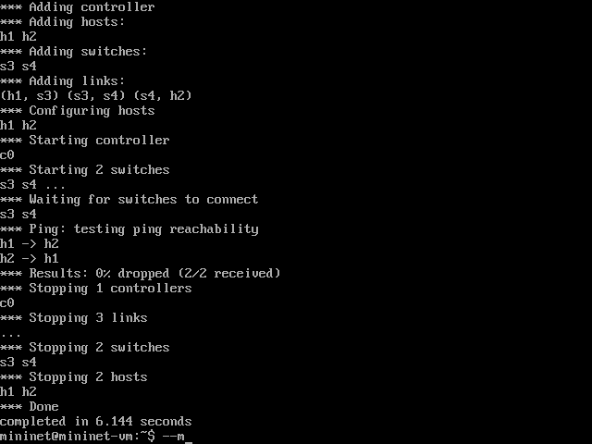

* **sudo mn –mac**

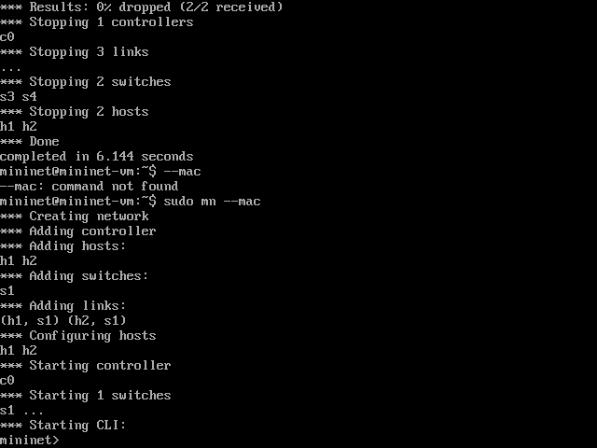

* **Sample Creating A Network**

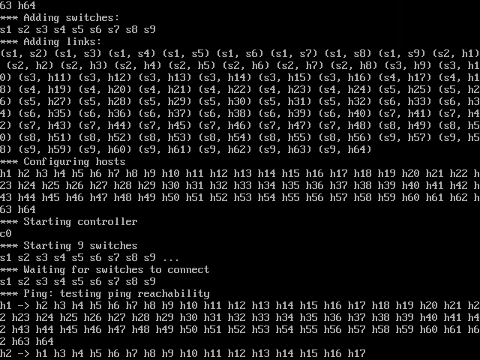

* **Interacting with Network**

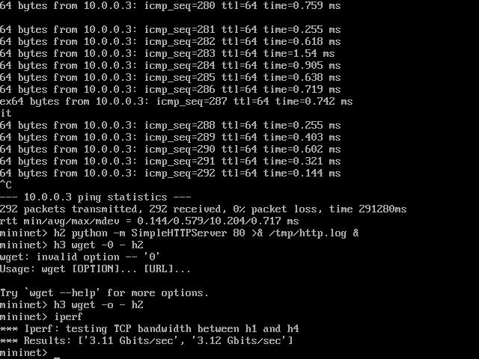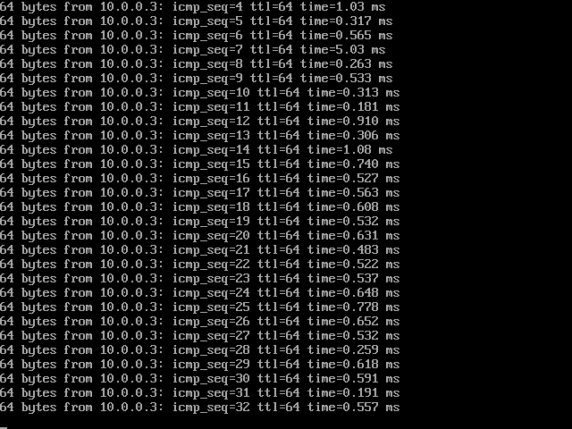

**MININAM :**

* **sudo apt-get install git python-imaging python-imaging.tk**

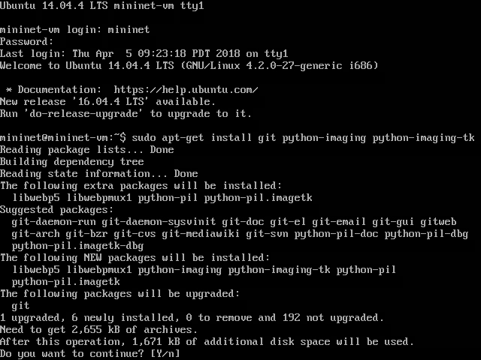

* **tree**

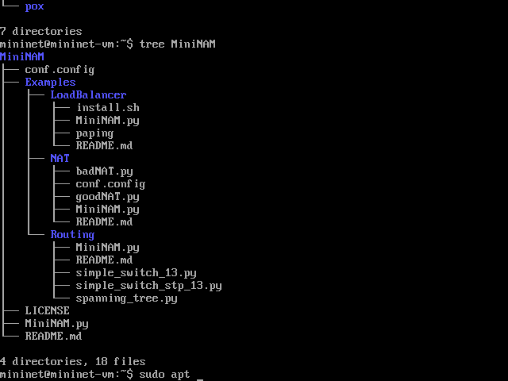

* **putty.exe –X –P 2222 –l mininet localhost**

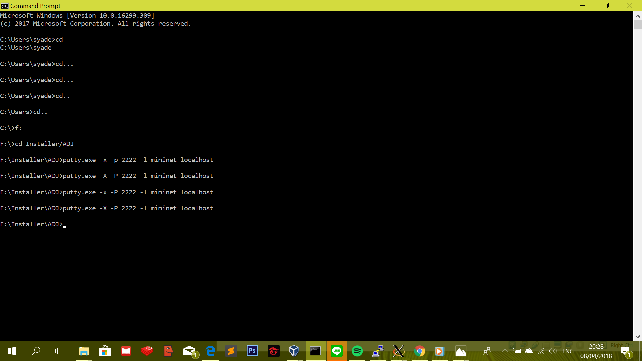

* **xterm**

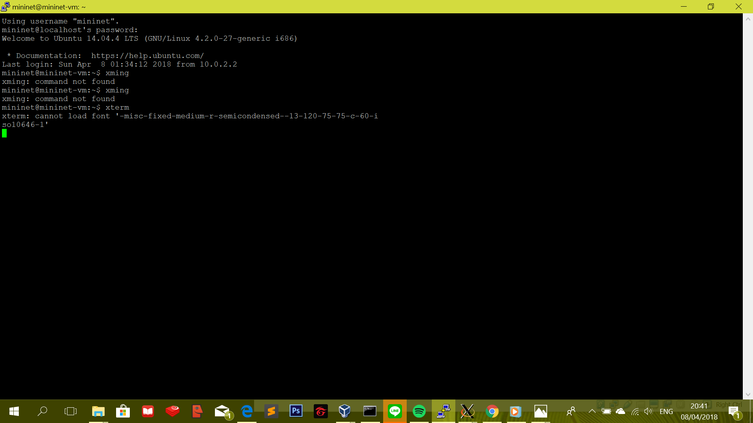

* **sudo python ~/MiniNAM/MiniNAM.py**

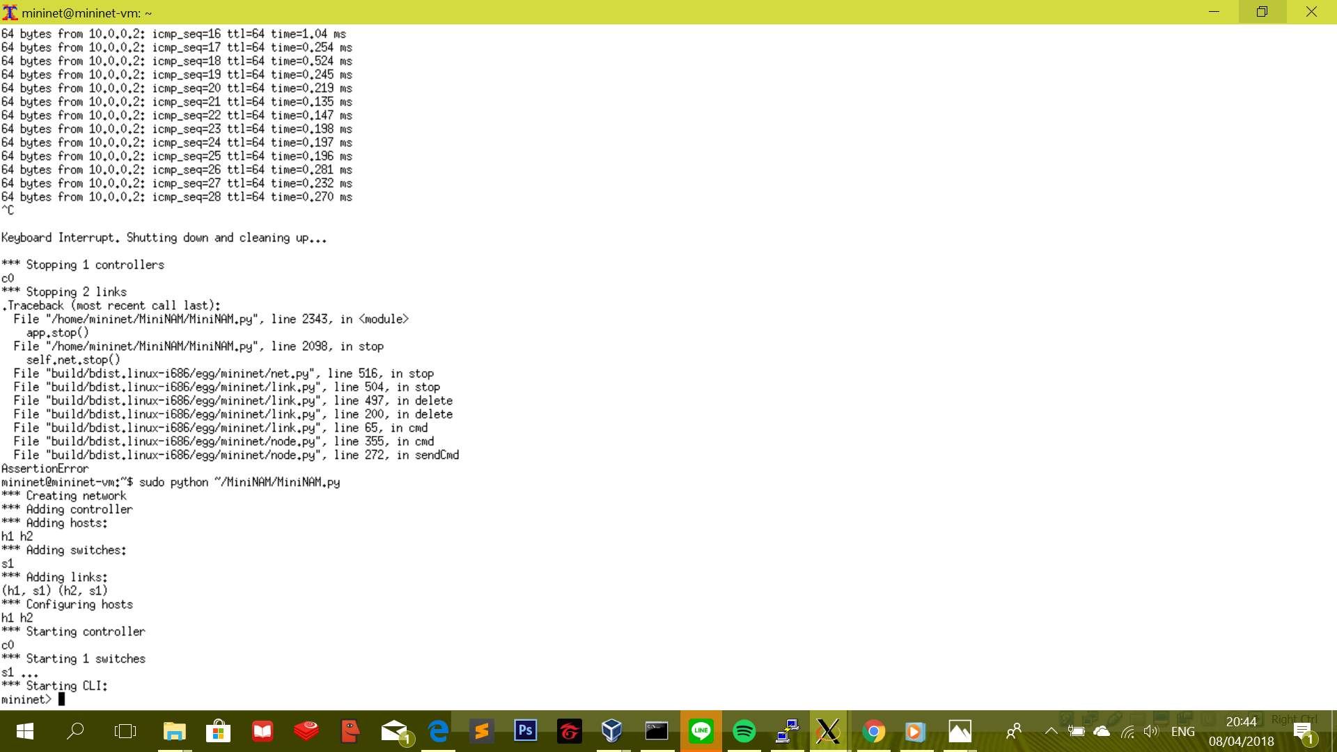

* **h1 ping –c2 h2**

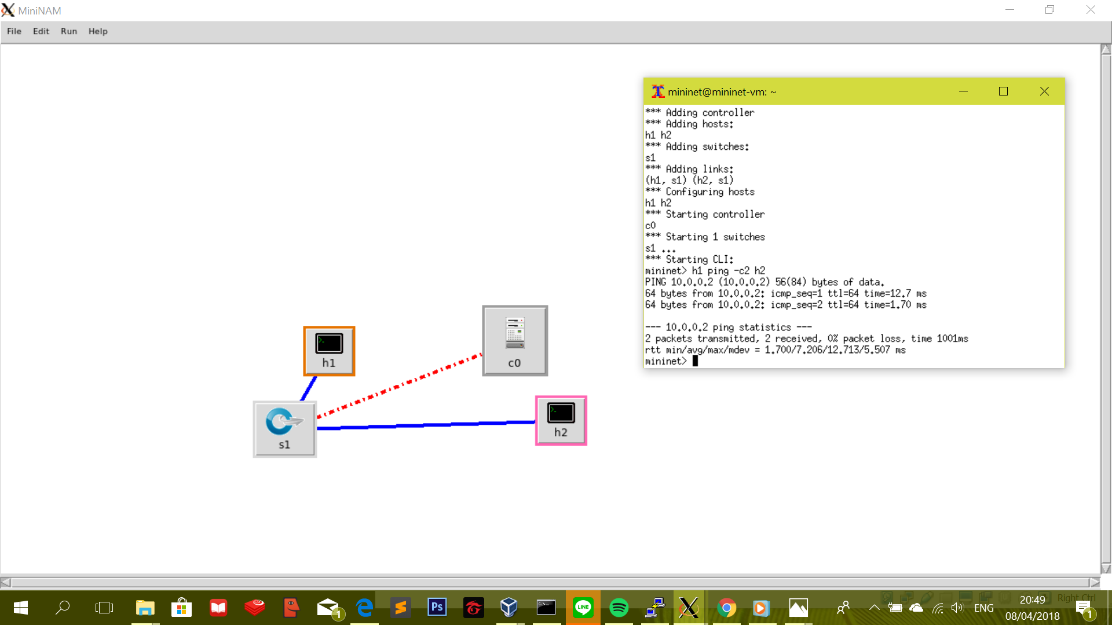

**OPENFLOW :**

* **sudo python ~/MiniNET/MiniNET.py –topo single,3 –mac –switch ovsk –controller remote**

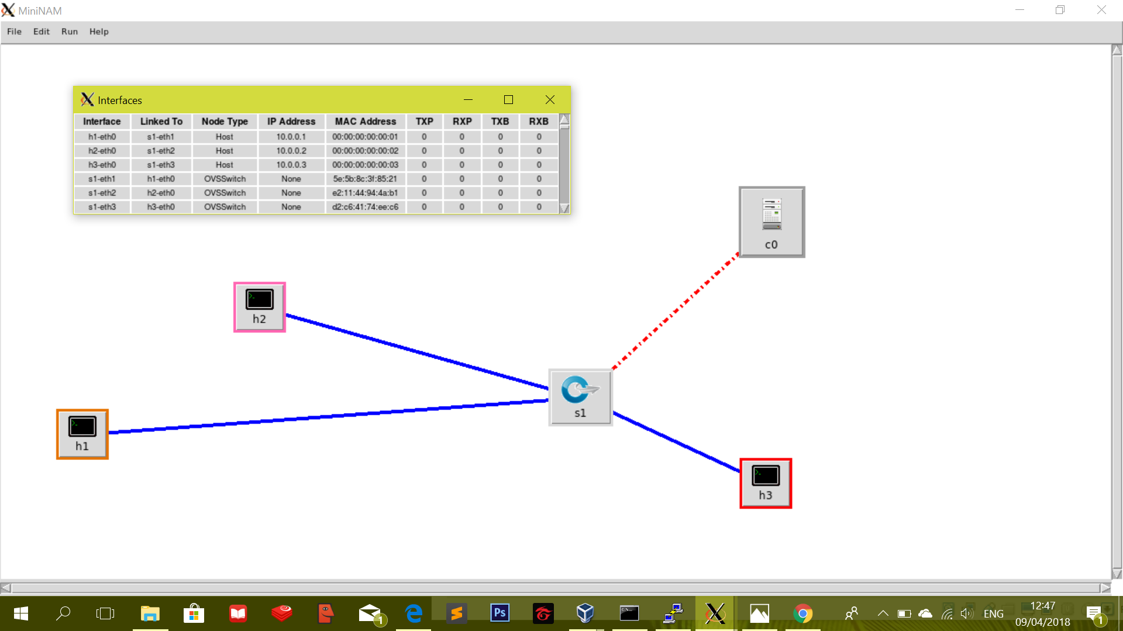

* **Manual Flow Entry**

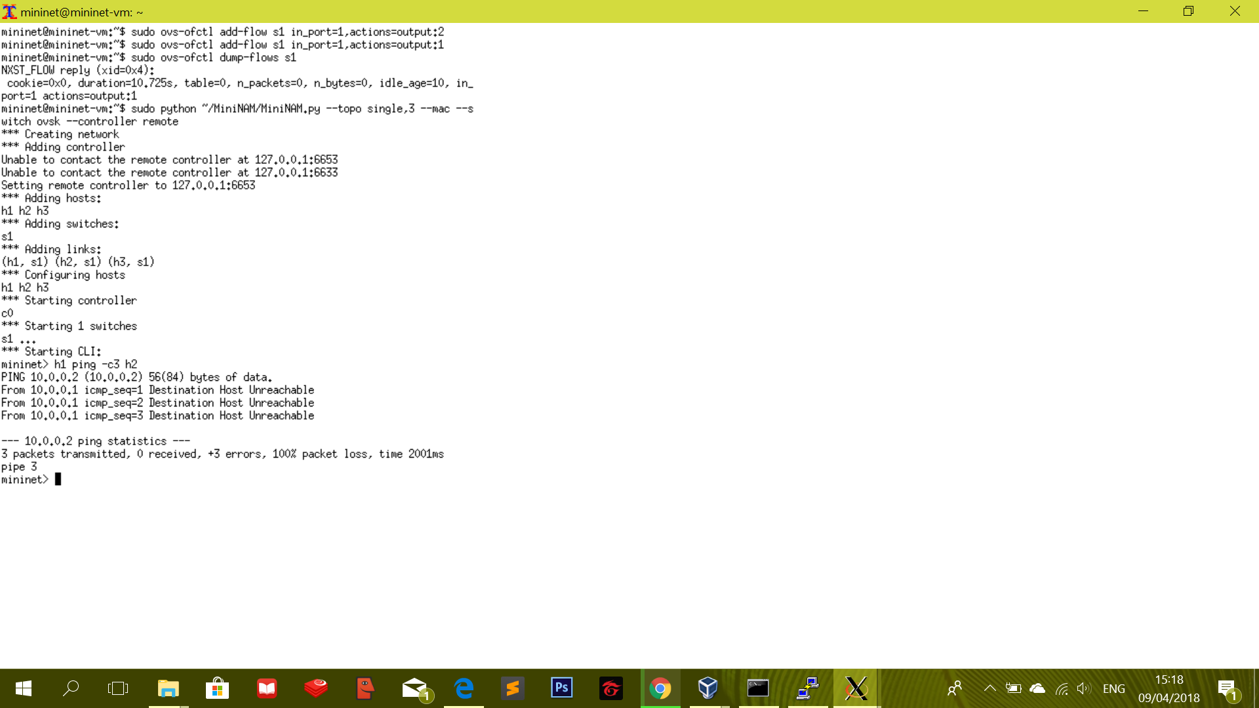

* **sh sudo wireshark &**

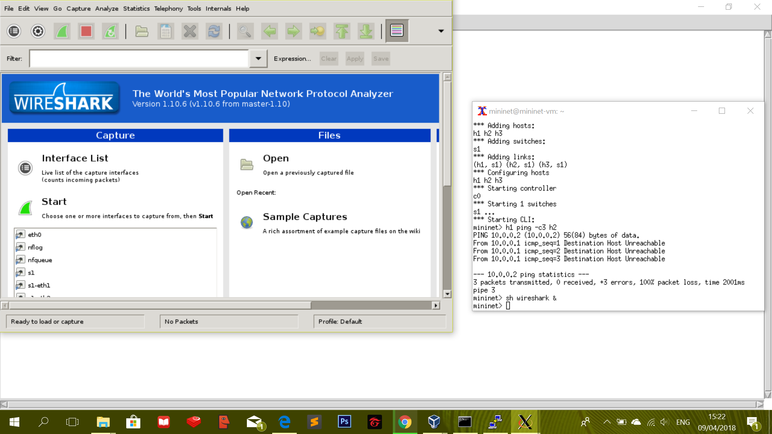

* **LoopBack**

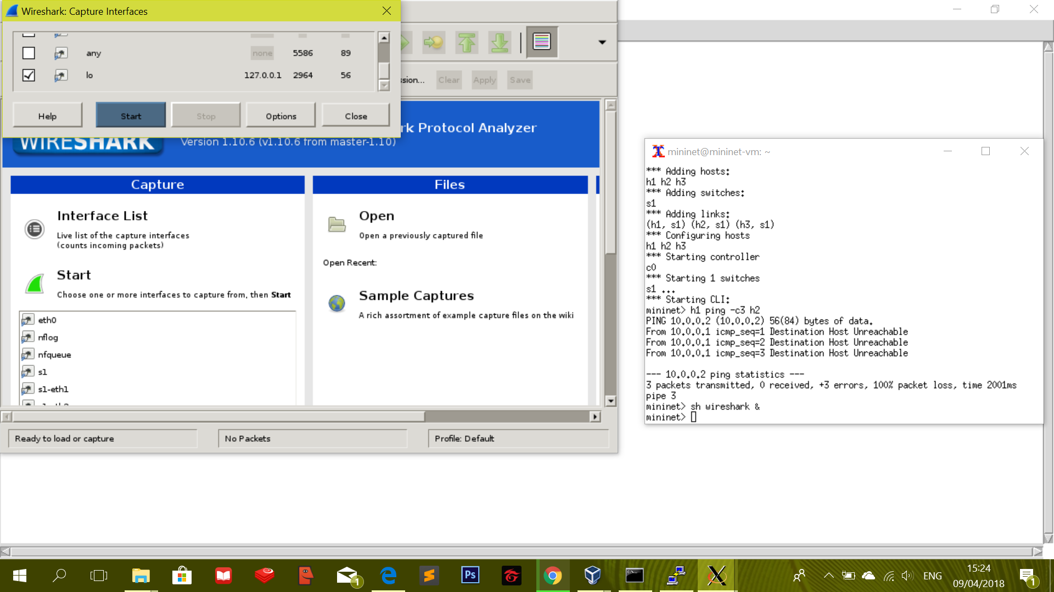

* **Starting Controller OF Reference Controller**

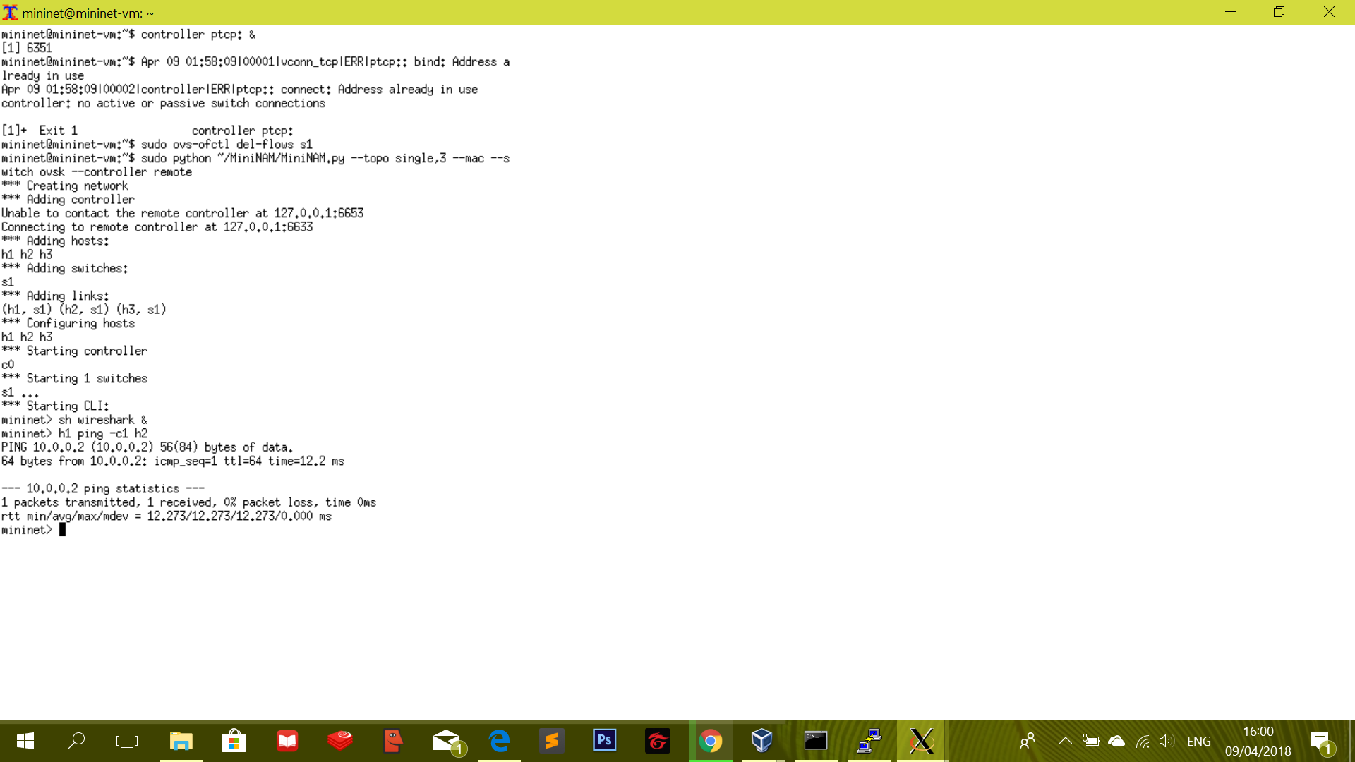

* **Filter OF**

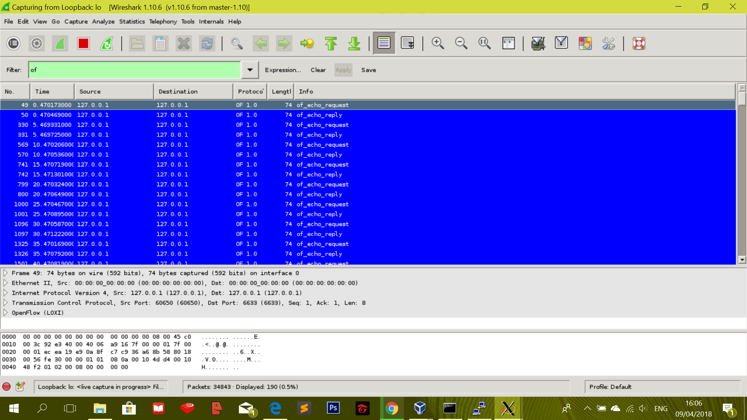

* **Inspect Packet**

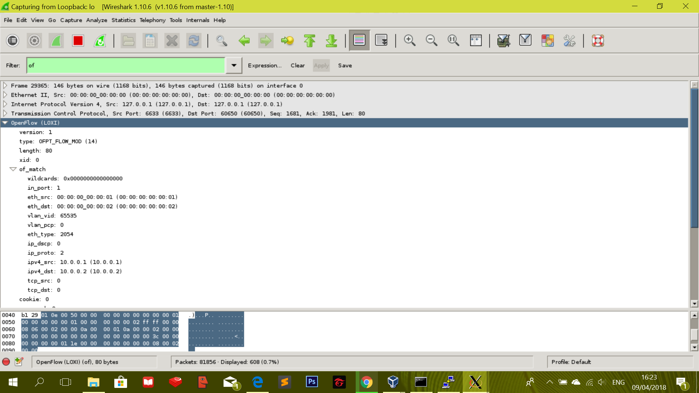

* **Of and Not**

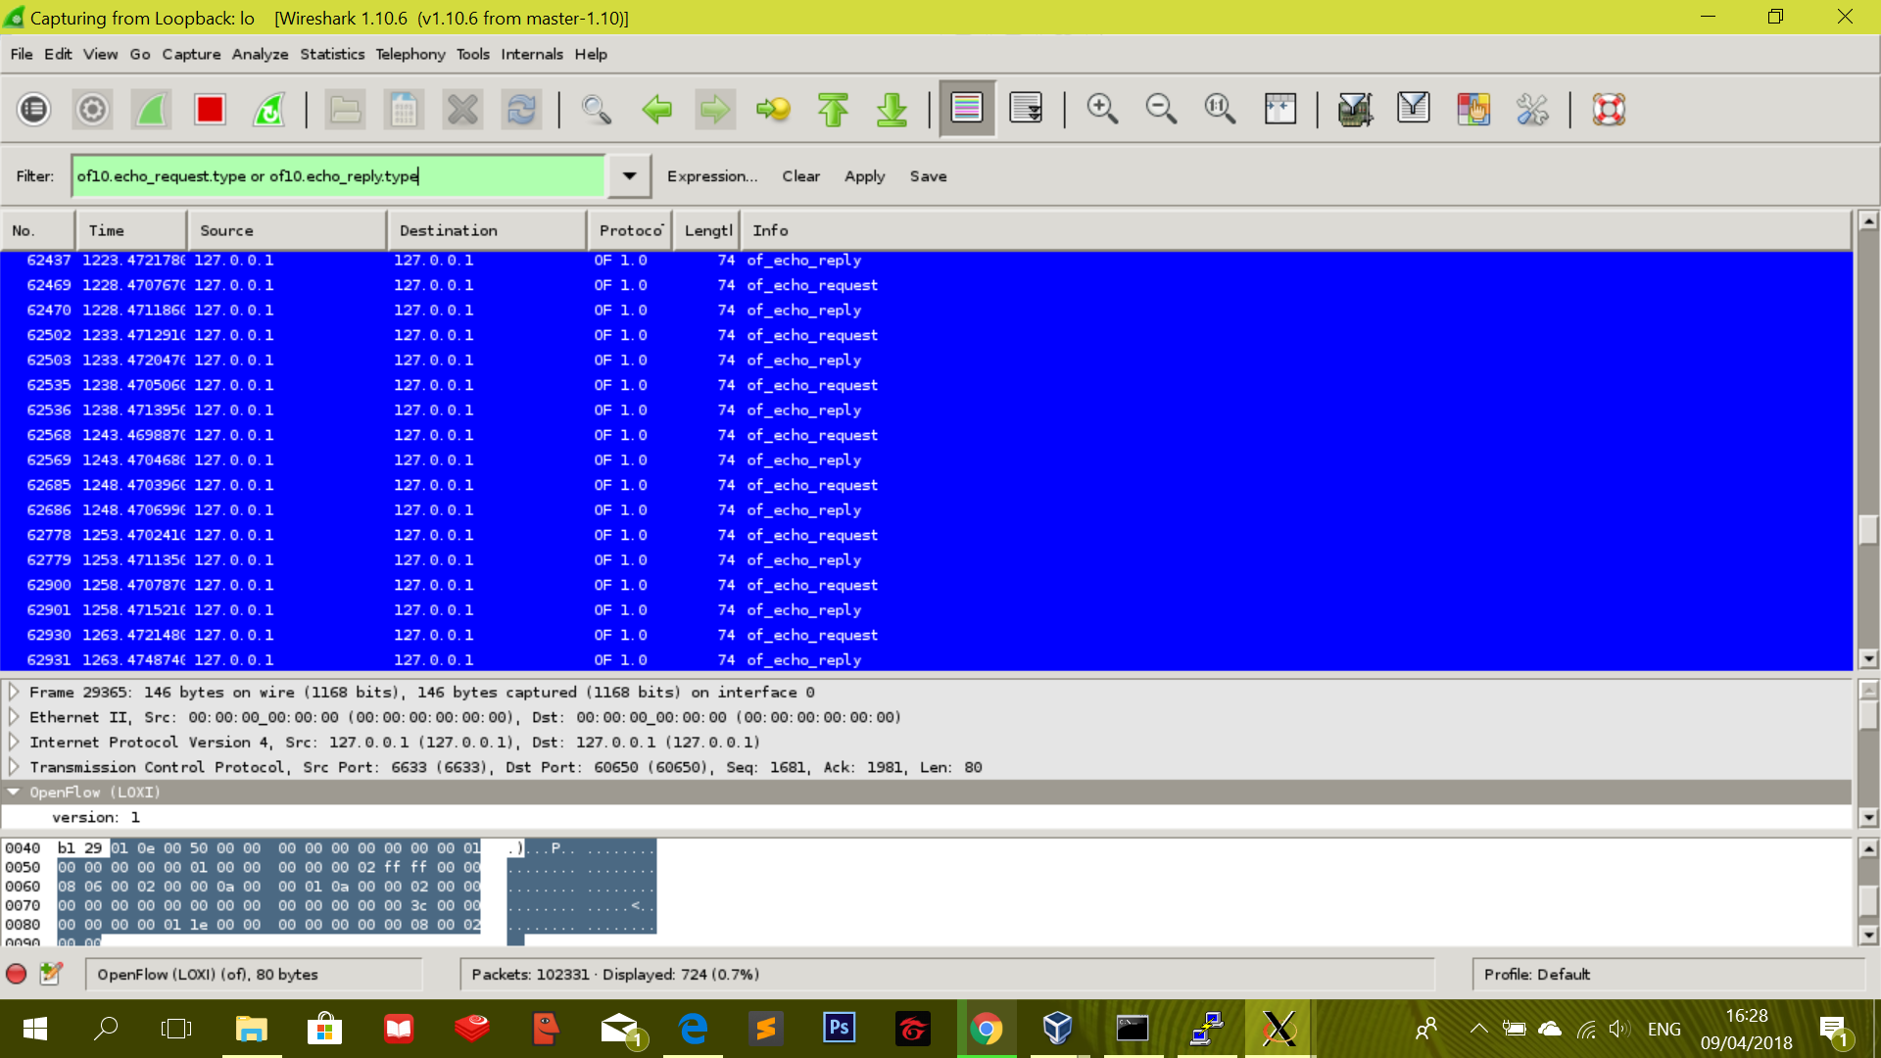

* **h1 ping –c1 h2**

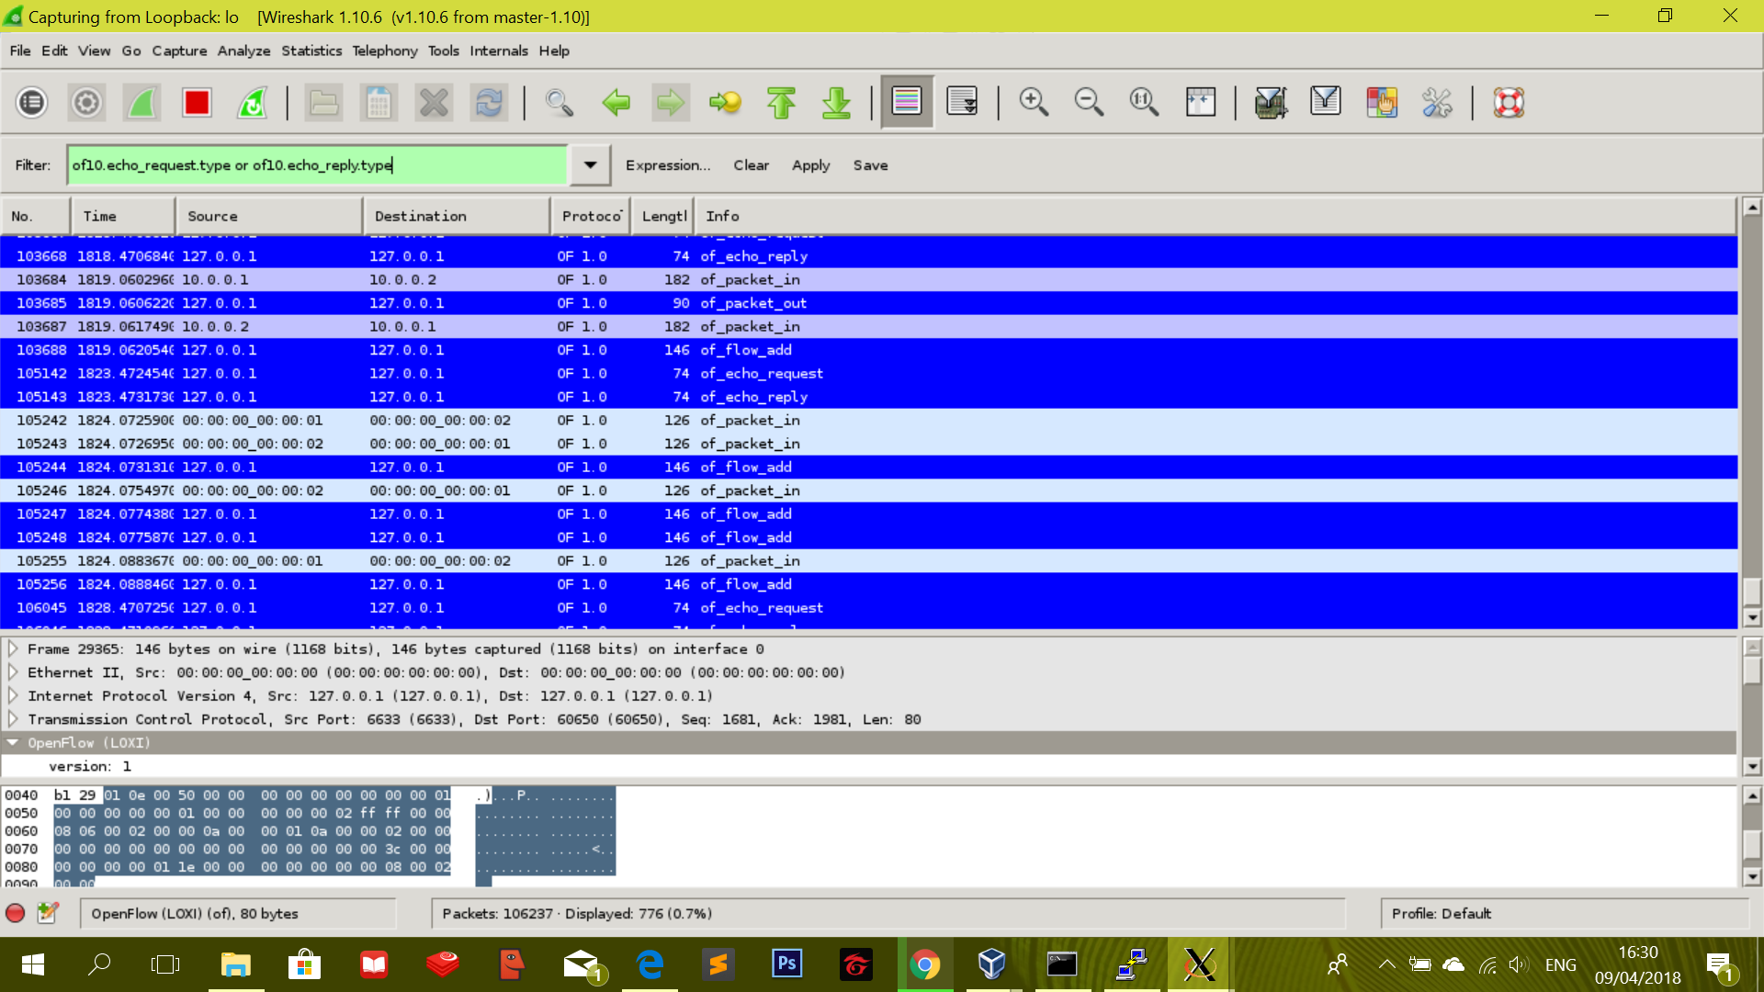

* **Benchmark with –kernel**

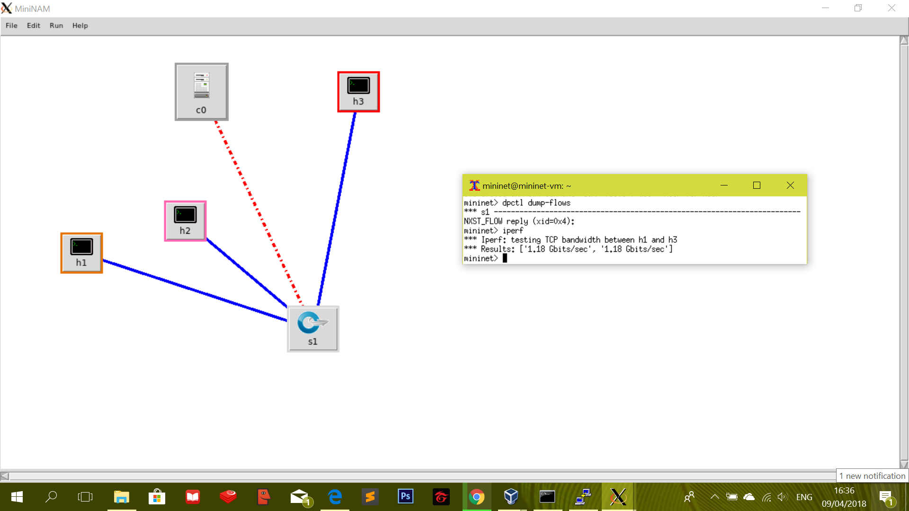

**POX Controller :**

* **POX Controller HUB Behavior**

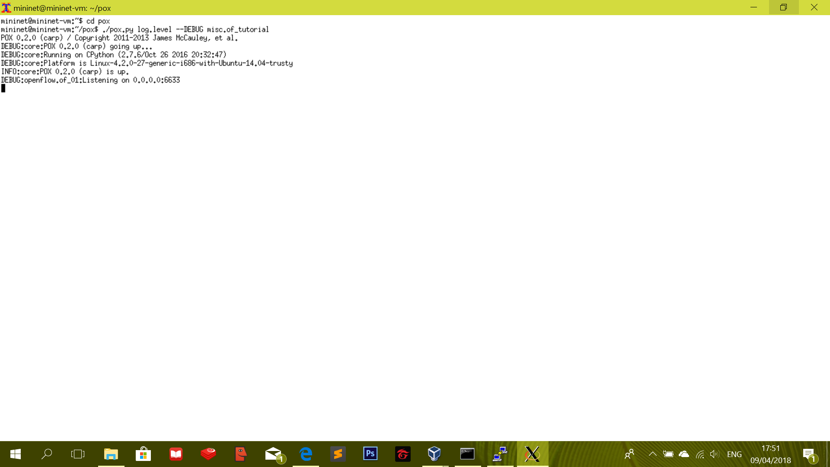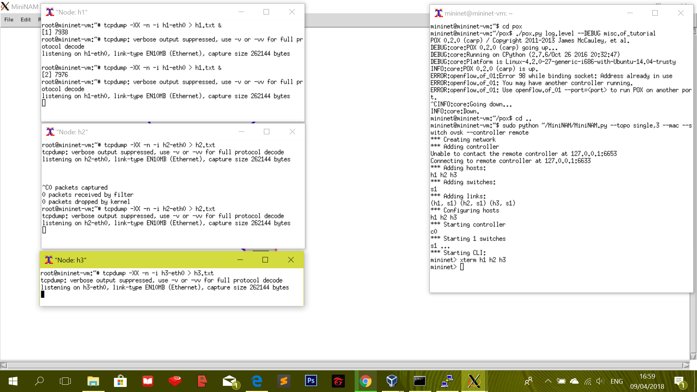

* **cat h1.txt, h2.txt, and h3.txt**

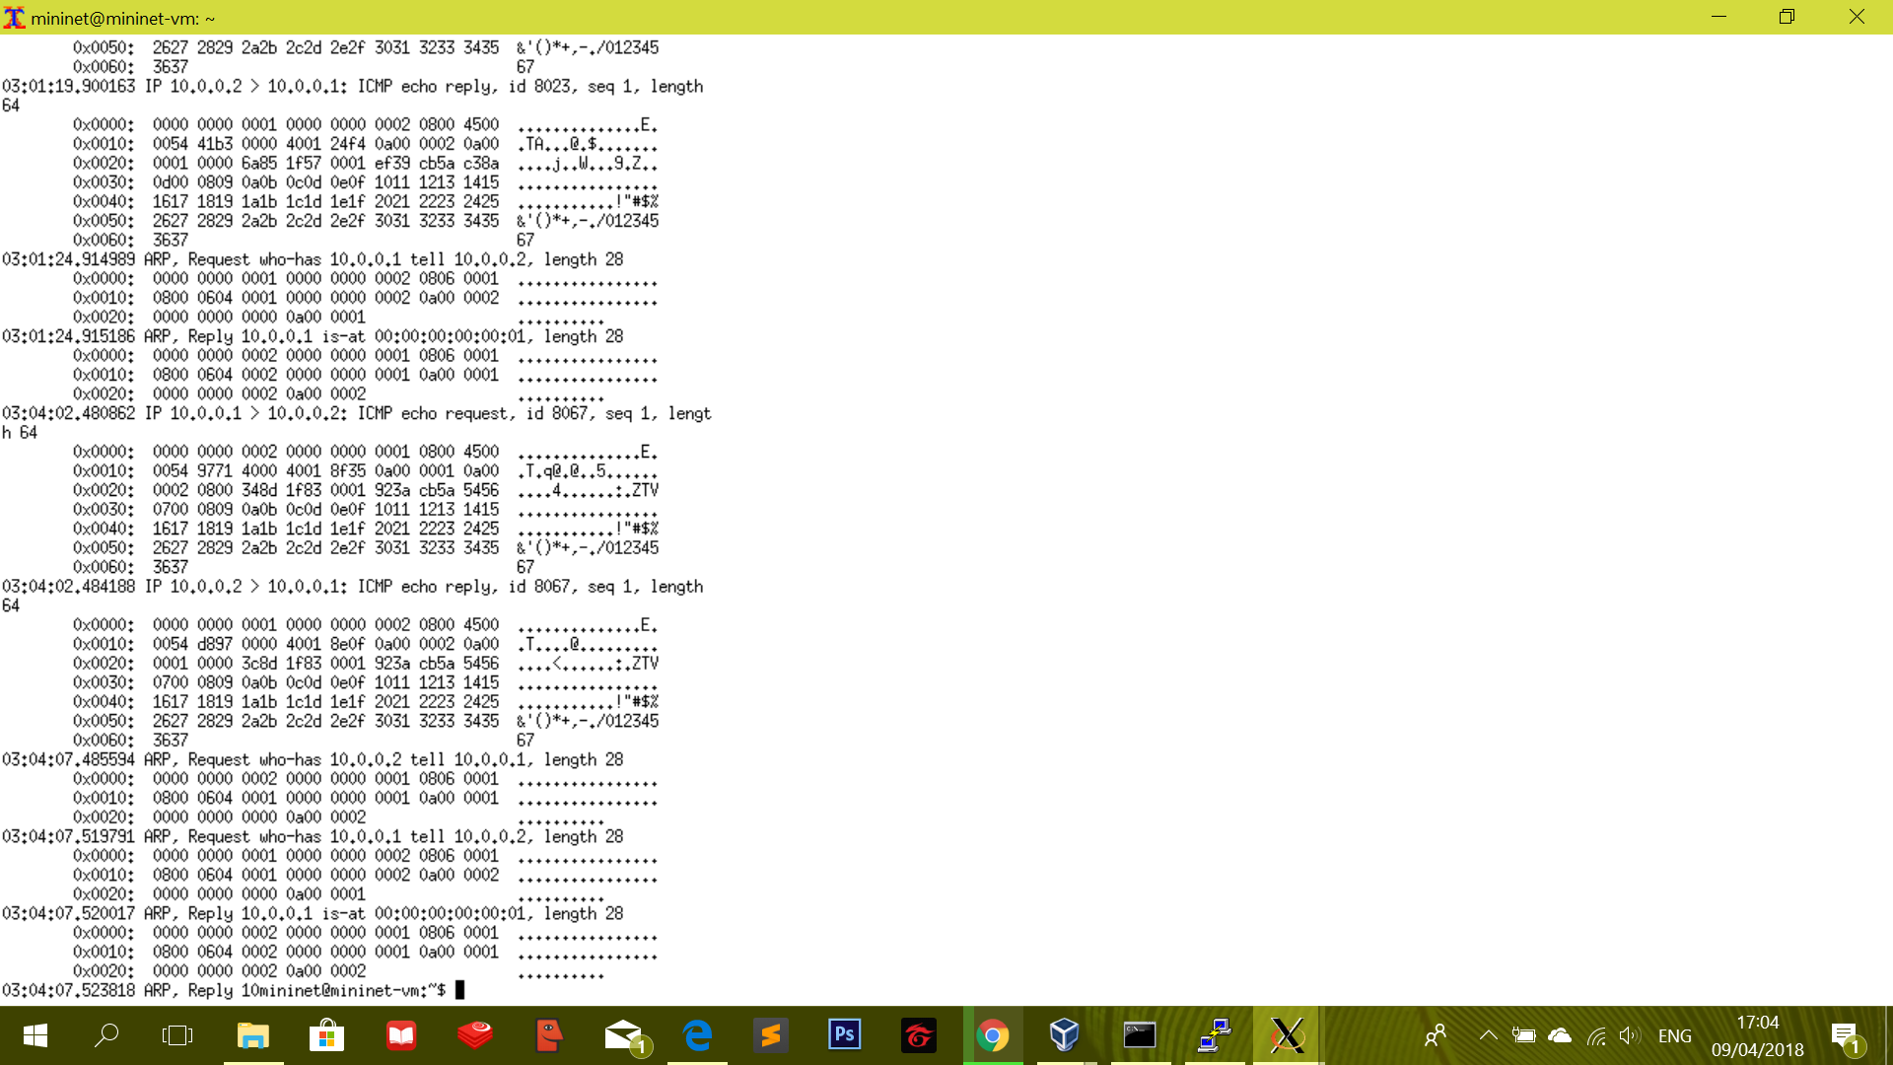

* **h1 ping –c1 10.0.0.2**

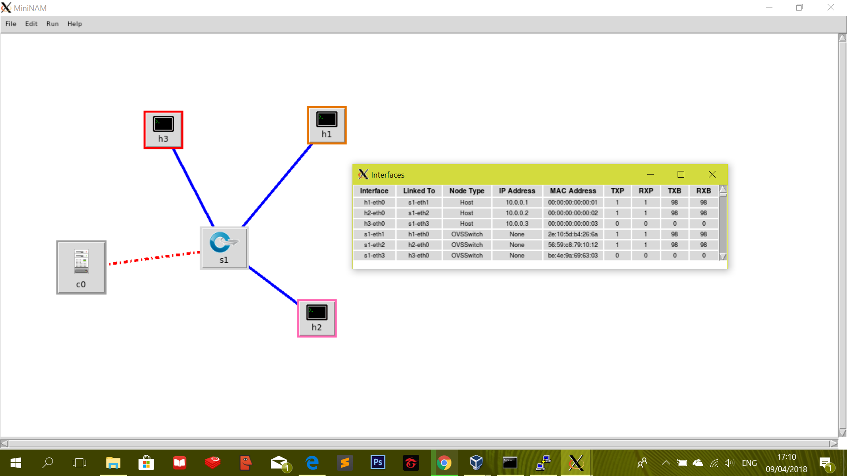

* **h1 ping –c1 10.0.0.5**

